Mendocino/Lake Adult and Career Education
(ML ACE) Meeting—Zoom Meeting

Mendocino College
1000 Hensley Creek Rd.
Ukiah CA 95482
via Zoom https://cccconfer.zoom.us/j/428562926
April 17, 2020 10:00 AM to 12:00 pm
Attendees: Euline Olinger, Christy Smith, Monica Whipple, Tami Mee, Noor Dawood, Brian Figg, Amanda Xu, Steve Barekman, Monica Gowan, Jeff Ritchley, Pam Jensen, Coni Belli, Joe Del Prete, Maggie Von Vogt, Jackeline Orozco, Margaret Rodier
Minutes
- Call to Order Start time: 10:06 am (Action)
- Roll Call of Voting Members (Action)
Tami Mee (MCOE), Noor Dawood (AVUSD), Brian Figg (ULUSD), Amanda Xu (MC), Christy Smith (UUSD), Monica Gowan (RVUSD), Jeff Ritchley (WUSD), Coni Belli (FBUSD), Joe Del Prete (KUSD), Beth Hampson (LCOE)
- Changes/ Modifications to the Agenda (Action)
Item #7b is going to be removed from the agenda. Euline shared that Mendocino College will be funding proposals.
Item #9c will be changed to 9b
Motion to approve changes made by Joe Del Prete/ Christy Smith - Approved
- Public Comments/ Correspondents --via Zoom (Discussion)
There was no public input. Consent (Action)
All consent items are acted upon by a single vote with no discussion unless pulled from Consent and placed on the agenda as a regular item.
- Approval of February 7, 2020 Minutes
Motion to approve February 7, 2020 Minutes made by Coni Belli/ Beth Hampson - Approved
- Overview of the next 6 months (Discussion)
Euline went over PowerPoint of the next 6 months due dates and meetings.
- One-time proposals ($5833 remaining) (Discussion/Action)
The consortium discussed changes on the approved one-time proposal from January 2020 funding according to ML ACE criteria and guidelines and voted on new proposals.
- Anderson Valley—GED workbooks, Two desktop computers $ 1708
Motion to approve two desktop computers in the amount of $1,046 made by Joe Del Prete/Coni Belli – Approved
Motion to approve BSK 501 502 course workbooks for students in the amount of $662 made by Joe Del Prete/Beth Hampson - Approved
- Fort Bragg—ESL books and supplies $3180 What happened with this?
B. Ukiah Unified--Nursing software update $6222
Motion to approve new online/distance learning for both teachers and students in the vocational nursing program in the amount of $6222 made by Joe Del Prete/Coni Belli - Approved
- Mendocino College—Fiesta Day Event canceled. This amount plus about $4000 added to remaining one-time funds.
- Approval of Consortium Fiscal Administration Declaration (Action/Discussion)

Euline presented CFAD with the dollar amount that each agency will be receiving. See Appendix B
Motion to approve CFAD made by Joe Del Prete / Beth Hampson - Approved
- Director’s Update: (Discussion)
  - Euline gave an update on the non-credit Construction and Computer Skills and Application curriculum
The curriculum is moving forward and Amanda Xu will be in contact to update.
  - Euline shared the CAE webinars and workshops. Distance Learning if 50% or more programs/classes will need to be logged as distance learning. CAEP
OTAN survey is open at this moment and (who would like?) would like all adult consortium members to take a survey that is specific to COVID 19 such as unemployment or other programs that are offered to the support of our population.
Community Pro Suite has an “Activity Timeline” that can help track any student contact.
- Member Updates—summary
  - Anderson Valley – Classes are meeting with distance learning and staff is meeting on Zoom.
  - Ft. Bragg USD – Three graduates from High School Diploma Program. ESL/Citizenship over Zoom is going well.
  - Kelseyville USD – Everything is going well. Joe is sending out packets.
  - Lake COE – CNA still on hold. We are continuing to connect with the Lake County Public Health Officer regarding this program’s status. MA is meeting via Zoom, Google Classroom, and packets. MA is on track to finish the program by their regular end date (late May), including certification testing. All MA students completed their clinical hours prior to facilities limiting student presence for externships. HiSET at the Lake County Jail is still on hold, as visitors for educational purposes and HISET paper-based testing are both not permitted at this time
  - Mendocino COE - MA is meeting via Zoom and packets, doing as well as can be expected. Phlebotomy has been more challenging. Trying to use online resources, however, the publisher's website has had issues, likely due to so many suddenly trying to access it. Also, waiting on approval from CDPHLFS for approval for Zoom courses for Phlebotomy. I still need a Dental Assistant Instructor, and working on a schedule for the next MA to start in August.
  - Mendocino College (Centers, HEP) – Amanda updated on MC online/distance learning. Summer MC on-ground courses have either been canceled or transitioned to online courses. For the Fall the college still plans on listing all classes but will have more information as time goes on.
Jackie shared that the HEP is still providing services through many different platforms.
  - Round Valley – Things are going well. High School Diploma teacher has been reaching out to students and is handing out packets for students. ESL and BSK instructors are also reaching out to the students and offering the Round Valley Classroom as a meeting place.
  - Ukiah USD – Pam from UVAH shared her staff now has cell phones to call in and check on their students. Her staff has also started doing drive-by’s to check in on students. They are offering classes on the computer such as exercise and cooking classes.
Christy – HSD and ESL and Citizenship are continuing and the teacher is on-site. They see students one on one. The jail is still working independently. Person Vue testing is still administering every Tuesday.
  - Upper Lake USD – Brian shared that students are working remotely as they have been. Students are picking up and dropping off packets.
  - Willits USD – Jeff shared that students are still attending. Students are coming in, picking up and dropping off packets.
- Next Meeting Date and Time (Action)
  - May 8, 2020, 10-12 pm. via Zoom
- Adjourn End time: 12:05 (Action)
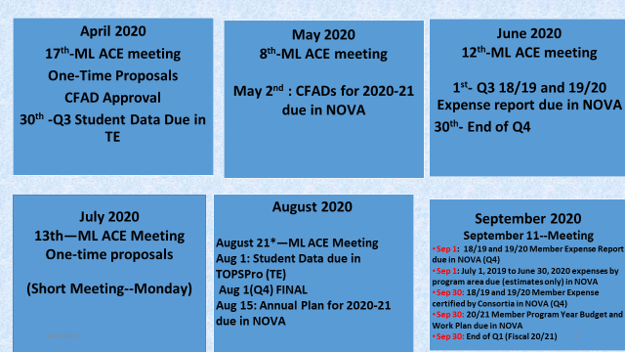
Appendix A
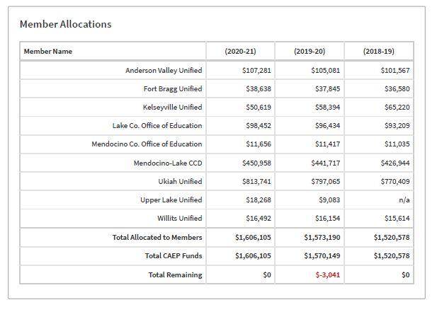
Appendix B

